**PIZZA SALES SQL QUERIES**

1. **KPI**
2. Total Revenue

SELECT SUM(total_price) AS Total_Revenue from pizza_sales

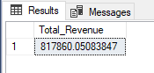

1. Average Order Value

select SUM(total_price) / COUNT(Distinct order_id) as Average_Order_value from pizza_sales

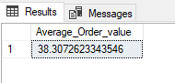

1. Total Pizza Sold

select SUM(quantity) as Total_Pizza_Sold from pizza_sales

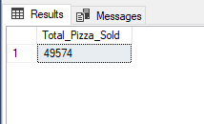

1. Total Orders Placed

select COUNT(DISTINCT order_id) as Total_Orders_placed from pizza_sales

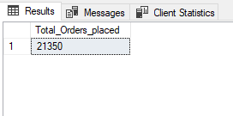

1. Average Pizza Per Order

select CAST( sum(quantity) AS DECIMAL(10,2)) / COUNT(DISTINCT order_id) as Average_pizza_per_order from pizza_sales

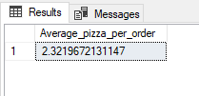

1. Daily Trend For Total Order

SELECT DATENAME(DW, order_date) as order_day, COUNT(DISTINCT order_id)

AS Total_Orders from pizza_sales

GROUP BY DATENAME(DW, order_date)

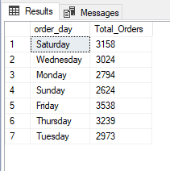

1. Hourly Trend For Total Orders

SELECT DATEPART(HOUR, order_time) as Order_Hours, COUNT(DISTINCT order_id) as Total_orders

from pizza_sales

GROUP BY DATEPART(HOUR, order_time)

ORDER BY DATEPART(HOUR, order_time)

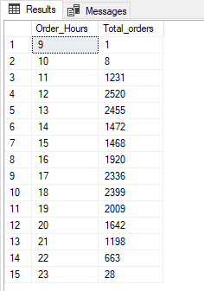

1. Percentage of Sales by Pizza Category

select pizza_category, sum(total_price) * 100 / (select sum(total_price) from pizza_sales)

from pizza_sales AS Percentage_of_Total_Sales

GROUP BY pizza_category

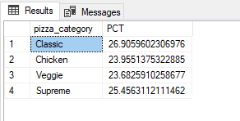

1. Sales Month-Wise

select pizza_category,sum(total_price) as Total_Sales,

sum(total_price) * 100 /

(select sum(total_price) from pizza_sales where MONTH(order_date) = 1) as PCT

from pizza_sales

where MONTH(order_date) = 1

GROUP BY pizza_category

(FOR JANUARY)

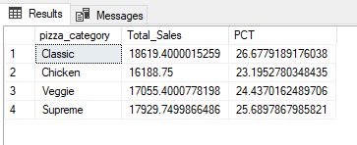

1. Percentage of Sales By Pizza Category

select pizza_size,sum(total_price) as Total_Sales,

CAST(sum(total_price) * 100 /

(select sum(total_price) from pizza_sales) as decimal(10,2)) as PCT

from pizza_sales

GROUP BY pizza_size

ORDER BY PCT DESC

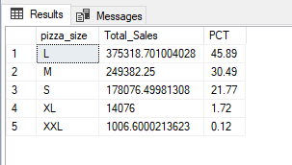

1. Total Pizza Sold by Category

select pizza_category, sum(quantity) as Total_Pizzas_Sold

from pizza_sales

GROUP BY pizza_category

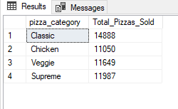

1. Top 5 Best Sellers by Total Pizza Sold

select TOP 5 pizza_name, sum(quantity) as Total_pizzas_Sold

from pizza_sales

GROUP BY pizza_name

ORDER BY sum(quantity) DESC

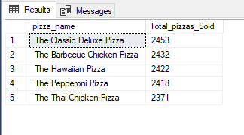

1. Top 5 Least Sellers by Total Pizza Sold

select TOP 5 pizza_name, sum(quantity) as Total_pizzas_Sold

from pizza_sales

GROUP BY pizza_name

ORDER BY sum(quantity) ASC

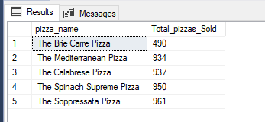

**NOTE**

If you want to apply the Month, Quarter, Week filters to the above queries you

can use WHERE clause. Follow some of below examples

SELECT DATENAME(DW, order_date) as Order_Day COUNT(DISTINCT order_id) as Total_Orders

from pizza_sales

WHERE MONTH(order_date) = 1

GROUP BY DATENAME(DW, order_date)

*Here = 1 indicates that the output is for the month of January•

4 indicates output for month of April.

SELECT DATENAME(DW, order_date) as Order_Day COUNT(DISTINCT order_id) as Total_Orders

from pizza_sales

WHERE DATEPART(QUARTER, order_date) = 1

GROUP BY DATENAME(DW, order_date)

*Here DATEPART(QUARTER, order_date) = 1 indicates that the output is for Quarter 1.